FEATURE SELECTION (Chi-Square, MI, RF Importance)
1. CHI-SQUARE TEST
--------------------------------------------------------------------------------
Feature Chi2_Score P_Value
Status Aplikasi 261.356315 8.687099e-59
Hasil Prescreening Dukcapil 58.298701 2.251927e-14
Hasil Prescreening DHNBI 31.475248 2.019989e-08
Produk 2.212969 1.368551e-01
Hasil Prescreening SIPKUR 1.342741 2.465512e-01
Sub Produk 1.253607 2.628647e-01
Pekerjaan 0.463563 4.959636e-01
Jangka Waktu 0.036460 8.485681e-01
Plafond 0.005163 9.427208e-01
Status Pernikahan 0.000288 9.864514e-01
Usia 0.000234 9.878059e-01

2. MUTUAL INFORMATION
--------------------------------------------------------------------------------
Feature MI_Score
Status Aplikasi 0.241136
Produk 0.025440
Hasil Prescreening Dukcapil 0.022721
Sub Produk 0.014078
Hasil Prescreening DHNBI 0.014032
Plafond 0.011758
Pekerjaan 0.001533
Status Pernikahan 0.000000
Usia 0.000000
Jangka Waktu 0.000000
Hasil Prescreening SIPKUR 0.000000

3. RANDOM FOREST FEATURE IMPORTANCE
--------------------------------------------------------------------------------
Feature Importance
Status Aplikasi 0.479316
Hasil Prescreening Dukcapil 0.148729
Plafond 0.110028
Usia 0.091506
Jangka Waktu 0.074250
Pekerjaan 0.045549
Hasil Prescreening SIPKUR 0.014392
Status Pernikahan 0.011514
Hasil Prescreening DHNBI 0.010706
Sub Produk 0.008858
Produk 0.005152

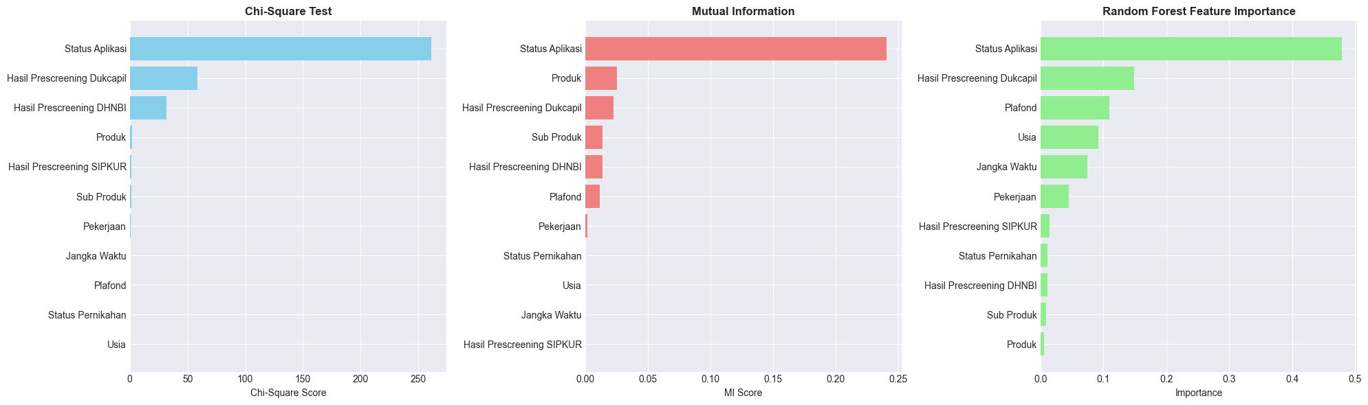

MASUK KE PROSES KOMBINASI DAN ELIMINASI FEATURE
RECURSIVE FEATURE ELIMINATION DAN AVARAGE
Final Selected Features (sorted by combined score):
1. Pekerjaan (Score: 0.8264) RFE Score
2. Usia (Score: 0.1591) RFE Score
3. Status Pernikahan (Score: 0.1082) Score
4. Produk (Score: 0.0528) Score
5. Sub Produk (Score: 0.0459) Score
6. Plafond (Score: 0.0330) RFE Score
7. Jangka Waktu (Score: 0.0075) RFE Score
8. Hasil Prescreening SIPKUR (Score: 0.0039) RFE
9. Hasil Prescreening Dukcapil (Score: 0.0036) RFE
10. Status Aplikasi (Score: 0.0017) RFE

TRAINING MODELS WITH 4 SCENARIOS
================================================================================

================================================================================
SCENARIO: 80-20 Split
================================================================================
Training size: 1200, Test size: 300

Training Random Forest...
✓ Random Forest | Acc: 0.9200 | Prec: 0.7917 | Rec: 0.9500 | F1: 0.8636 | AUC: 0.9432

Training XGBoost...
✓ XGBoost | Acc: 0.9100 | Prec: 0.7849 | Rec: 0.9125 | F1: 0.8439 | AUC: 0.9448

Training LightGBM...
✓ LightGBM | Acc: 0.9200 | Prec: 0.7979 | Rec: 0.9375 | F1: 0.8621 | AUC: 0.9474

Training Gradient Boosting...
✓ Gradient Boosting | Acc: 0.9167 | Prec: 0.7957 | Rec: 0.9250 | F1: 0.8555 | AUC: 0.9470

================================================================================
SCENARIO: 70-30 Split
================================================================================
Training size: 1050, Test size: 450

Training Random Forest...
✓ Random Forest | Acc: 0.9222 | Prec: 0.7891 | Rec: 0.9667 | F1: 0.8689 | AUC: 0.9552

Training XGBoost...
✓ XGBoost | Acc: 0.9133 | Prec: 0.7755 | Rec: 0.9500 | F1: 0.8539 | AUC: 0.9505

Training LightGBM...
✓ LightGBM | Acc: 0.9156 | Prec: 0.7808 | Rec: 0.9500 | F1: 0.8571 | AUC: 0.9501

Training Gradient Boosting...
✓ Gradient Boosting | Acc: 0.9133 | Prec: 0.7832 | Rec: 0.9333 | F1: 0.8517 | AUC: 0.9533

================================================================================
SCENARIO: 60-40 Split
================================================================================
Training size: 900, Test size: 600

Training Random Forest...
✓ Random Forest | Acc: 0.9217 | Prec: 0.7811 | Rec: 0.9812 | F1: 0.8698 | AUC: 0.9553

Training XGBoost...
✓ XGBoost | Acc: 0.9167 | Prec: 0.7895 | Rec: 0.9375 | F1: 0.8571 | AUC: 0.9534

Training LightGBM...
✓ LightGBM | Acc: 0.9150 | Prec: 0.7884 | Rec: 0.9313 | F1: 0.8539 | AUC: 0.9534

Training Gradient Boosting...
✓ Gradient Boosting | Acc: 0.9150 | Prec: 0.7946 | Rec: 0.9187 | F1: 0.8522 | AUC: 0.9545

================================================================================
SCENARIO: 10-Fold Cross Validation
================================================================================

Training Random Forest with 10-Fold CV...
✓ Random Forest | Acc: 0.9173 | Prec: 0.7870 | Rec: 0.9525 | F1: 0.8610 | AUC: 0.9487

Training XGBoost with 10-Fold CV...
✓ XGBoost | Acc: 0.9160 | Prec: 0.7873 | Rec: 0.9475 | F1: 0.8584 | AUC: 0.9524

Training LightGBM with 10-Fold CV...
✓ LightGBM | Acc: 0.9147 | Prec: 0.7880 | Rec: 0.9375 | F1: 0.8552 | AUC: 0.9516

Training Gradient Boosting with 10-Fold CV...
✓ Gradient Boosting | Acc: 0.9087 | Prec: 0.7837 | Rec: 0.9125 | F1: 0.8423 | AUC: 0.9491

COMPLETE COMPARISON: ALL MODELS × ALL SCENARIOS (Sorted by ROC-AUC)
================================================================================
Scenario Model Accuracy Precision Recall F1-Score ROC-AUC
60-40 Split Random Forest 0.921667 0.781095 0.981250 0.869806 0.955341
70-30 Split Random Forest 0.922222 0.789116 0.966667 0.868914 0.955202
60-40 Split Gradient Boosting 0.915000 0.794595 0.918750 0.852174 0.954467
60-40 Split XGBoost 0.916667 0.789474 0.937500 0.857143 0.953445
60-40 Split LightGBM 0.915000 0.788360 0.931250 0.853868 0.953445
70-30 Split Gradient Boosting 0.913333 0.783217 0.933333 0.851711 0.953321
10-Fold CV XGBoost 0.916000 0.787289 0.947500 0.858393 0.952420
10-Fold CV LightGBM 0.914667 0.788009 0.937500 0.855240 0.951636
70-30 Split XGBoost 0.913333 0.775510 0.950000 0.853933 0.950530
70-30 Split LightGBM 0.915556 0.780822 0.950000 0.857143 0.950051
10-Fold CV Gradient Boosting 0.908667 0.783661 0.912500 0.842251 0.949091
10-Fold CV Random Forest 0.917333 0.786991 0.952500 0.861047 0.948727
80-20 Split LightGBM 0.920000 0.797872 0.937500 0.862069 0.947386
80-20 Split Gradient Boosting 0.916667 0.795699 0.925000 0.855491 0.947045
80-20 Split XGBoost 0.910000 0.784946 0.912500 0.843931 0.944830
80-20 Split Random Forest 0.920000 0.791667 0.950000 0.863636 0.943239

SUMMARY BY SCENARIO (Average Metrics):
================================================================================
Accuracy Precision Recall F1-Score ROC-AUC
Scenario
10-Fold CV 0.914167 0.786488 0.937500 0.854233 0.950469
60-40 Split 0.917083 0.788381 0.942187 0.858248 0.954174
70-30 Split 0.916111 0.782166 0.950000 0.857925 0.952276
80-20 Split 0.916667 0.792546 0.931250 0.856282 0.945625

SUMMARY BY MODEL (Average Metrics):
================================================================================
Accuracy Precision Recall F1-Score ROC-AUC
Model
Gradient Boosting 0.913417 0.789293 0.922396 0.850407 0.950981
LightGBM 0.916306 0.788766 0.939063 0.857080 0.950629
Random Forest 0.920306 0.787217 0.962604 0.865851 0.950627
XGBoost 0.914000 0.784305 0.936875 0.853350 0.950306

BEST MODEL:
================================================================================
Scenario: 60-40 Split
Model: Random Forest
Accuracy: 0.9217
Precision: 0.7811
Recall: 0.9812
F1-Score: 0.8698
ROC-AUC: 0.9553
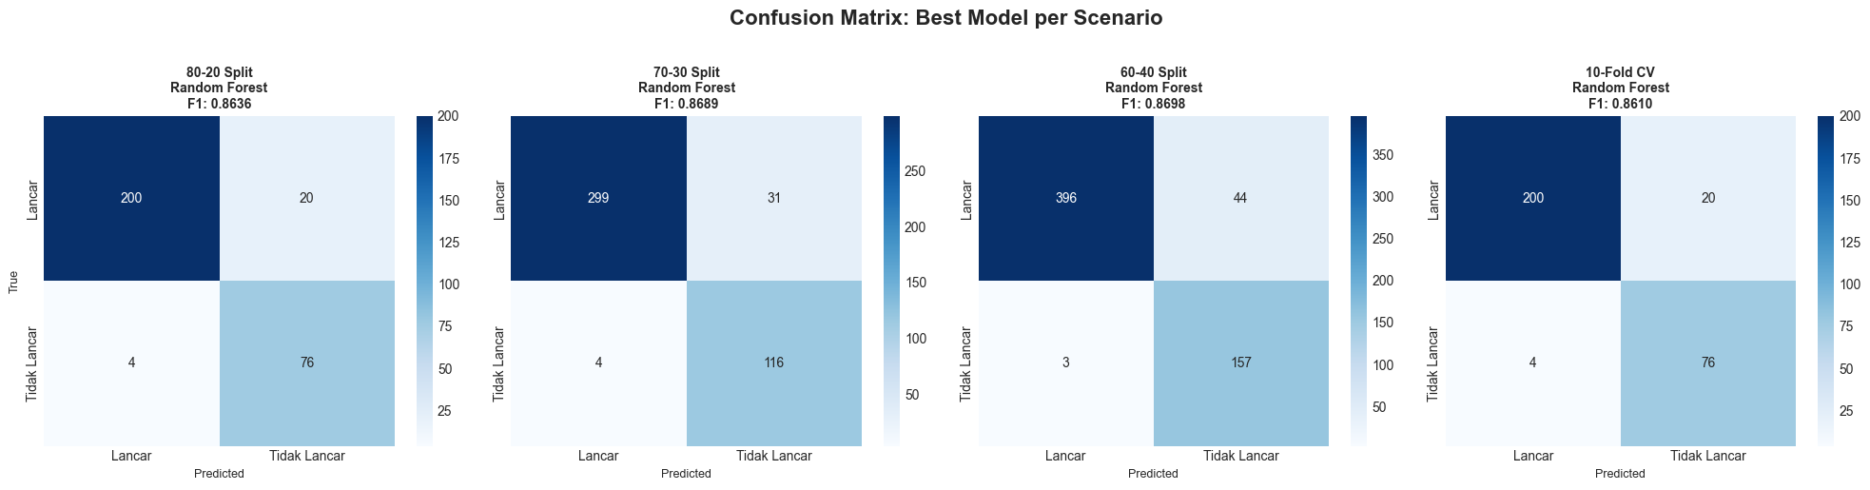
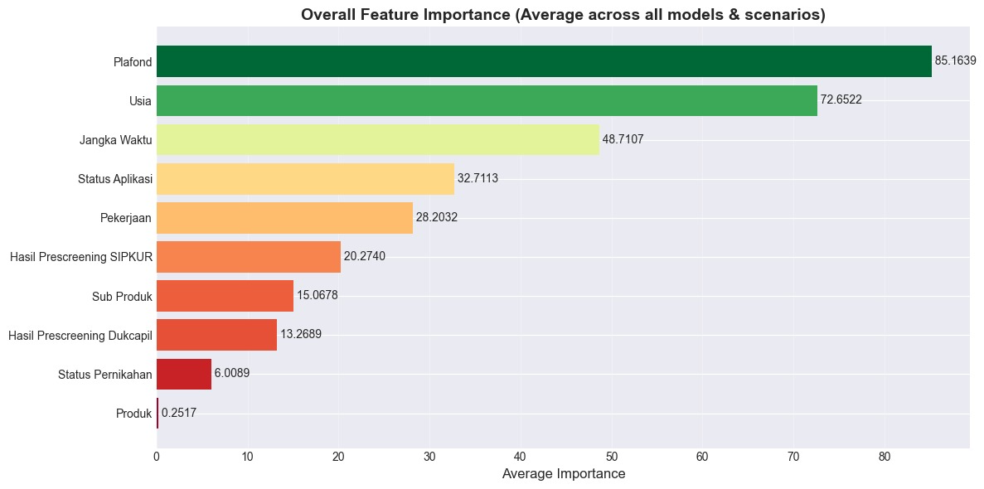

HYPERPARAMETER TUNING MODEL TERBAIK
CONTOH 10 KOMBINASI
Rank 1:
Mean ROC-AUC: 0.9530 (± 0.0173)
Parameters: {'n_estimators': 200, 'min_samples_split': 2, 'min_samples_leaf': 2, 'max_features': 'sqrt', 'max_depth': 10, 'bootstrap': True}
Rank 2:
Mean ROC-AUC: 0.9514 (± 0.0172)
Parameters: {'n_estimators': 200, 'min_samples_split': 2, 'min_samples_leaf': 2, 'max_features': 'log2', 'max_depth': 25, 'bootstrap': False}
Rank 2:
Mean ROC-AUC: 0.9514 (± 0.0173)
Parameters: {'n_estimators': 100, 'min_samples_split': 5, 'min_samples_leaf': 1, 'max_features': 'log2', 'max_depth': 10, 'bootstrap': True}
Rank 4:
Mean ROC-AUC: 0.9512 (± 0.0189)
Parameters: {'n_estimators': 100, 'min_samples_split': 2, 'min_samples_leaf': 2, 'max_features': 'sqrt', 'max_depth': 20, 'bootstrap': True}
Rank 4:
Mean ROC-AUC: 0.9512 (± 0.0180)
Parameters: {'n_estimators': 100, 'min_samples_split': 2, 'min_samples_leaf': 4, 'max_features': 'sqrt', 'max_depth': 15, 'bootstrap': False}
Rank 6:
Mean ROC-AUC: 0.9511 (± 0.0176)
Parameters: {'n_estimators': 200, 'min_samples_split': 10, 'min_samples_leaf': 4, 'max_features': 'sqrt', 'max_depth': 15, 'bootstrap': False}
Rank 7:
Mean ROC-AUC: 0.9510 (± 0.0165)
Parameters: {'n_estimators': 300, 'min_samples_split': 2, 'min_samples_leaf': 2, 'max_features': 'log2', 'max_depth': None, 'bootstrap': False}

Rank 8:
Mean ROC-AUC: 0.9510 (± 0.0178)
Parameters: {'n_estimators': 200, 'min_samples_split': 2, 'min_samples_leaf': 1, 'max_features': 'sqrt', 'max_depth': 15, 'bootstrap': True}

Rank 9:
Mean ROC-AUC: 0.9509 (± 0.0163)
Parameters: {'n_estimators': 300, 'min_samples_split': 2, 'min_samples_leaf': 2, 'max_features': 'log2', 'max_depth': 15, 'bootstrap': False}

BEST PARAMETERS SUMMARY
Model: Random Forest
Scenario: 60-40 Split
Optimized Parameters:
1. n_estimators = 200
2. min_samples_split = 2
3. min_samples_leaf = 2
4. max_features = sqrt
5. max_depth = 10
6. bootstrap = True
Performance:
Cross-Validation ROC-AUC: 0.9530
Test Set ROC-AUC: 0.9513
Test Set F1-Score: 0.8643

PEMILIHAN MODEL DENGAN PARAMETER YANG SUDAH DIDAPAT
Scenario: 60-40 Split
Model: Random Forest
Accuracy: 0.9217
Precision: 0.7783
Recall: 0.9875
F1-Score: 0.8705
ROC-AUC: 0.9546

PROTOTYPE
